**Homework week 4**

**Question 1 (**question 1**a** equals task 4a of week 3**)**

Two rangers in South-Africa (Elvis and Abedi) count the number of lions they have spotted per day. Elvis counts the lions in the Kruger Park and Abedi counts the lions in Umfolosi National Park.

Elvis: 12 14 12 12 14 17 18 9 10 11

Abedi: 25 4 12 13 29 11 15 20 0 11

1. **Compute the mean, median and mode**

**Mean:**

Elvis: 129/10 = **12.9**

Abedi:140/10 = **14**

**Median Elvis:**

|  |  |  |  |  |  |  |  |  |  |  |
| --- | --- | --- | --- | --- | --- | --- | --- | --- | --- | --- |
| Value | 9 | 10 | 11 | 12 | 12 | 12 | 14 | 14 | 17 | 18 |
| Position | 1 | 2 | 3 | 4 | 5 | 6 | 7 | 8 | 9 | 10 |

n = 10

The median is the average of the 5th and 6th value. The median is **12**.

**Median Abedi:**

|  |  |  |  |  |  |  |  |  |  |  |
| --- | --- | --- | --- | --- | --- | --- | --- | --- | --- | --- |
| Value | 0 | 4 | 11 | 11 | 12 | 13 | 15 | 20 | 25 | 29 |
| Position | 1 | 2 | 3 | 4 | 5 | 6 | 7 | 8 | 9 | 10 |

The median is the average of the 5th and 6th value, which is **12.5**

**Mode:**

The mode for Elvis 12. The value occurs 3 times, which makes the distribution unimodal

The mode for Abedi is 11. The value occurs 2 times, which makes the distribution unimodal

1. 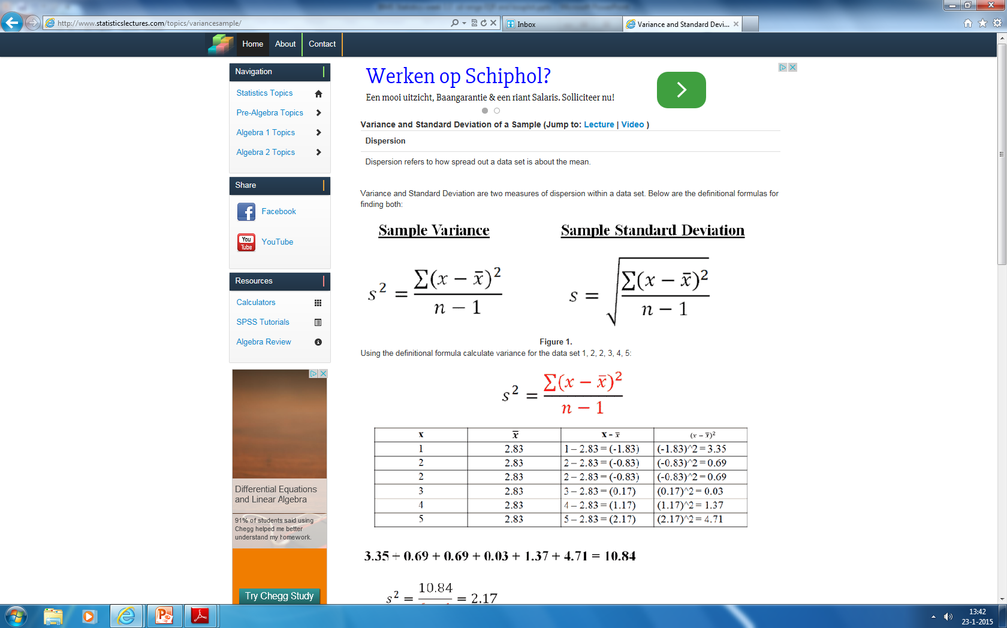**Calculate the standard deviation for Elvis and Abedi**

**Elvis:**

|  |  |  |
| --- | --- | --- |
| **Value** | **x - mean** | **Squared difference** |
| 9 | -3,9 | 15,21 |
| 10 | -2,9 | 8,41 |
| 11 | -1,9 | 3,61 |
| 12 | -0,9 | 0,81 |
| 12 | -0,9 | 0,81 |
| 12 | -0,9 | 0,81 |
| 14 | 1,1 | 1,21 |
| 14 | 1,1 | 1,21 |
| 17 | 4,1 | 16,81 |
| 18 | 5,1 | 26,01 |
|  | **Total** | **74,9** |

74.9/(10-1) = **8.3**

**Abedi:**

|  |  |  |
| --- | --- | --- |
| Value | x - mean | Squared difference |
| 0 | -14 | 196 |
| 4 | -10 | 100 |
| 11 | -3 | 9 |
| 11 | -3 | 9 |
| 12 | -2 | 4 |
| 13 | -1 | 1 |
| 15 | 1 | 1 |
| 20 | 6 | 36 |
| 25 | 11 | 121 |
| 29 | 15 | 225 |
|  | **Total** | **702** |

702/(10-1) = **78**

**Elvis:** √8,3 = 2,9 (lions)

**Abedi:** √78 = 8.8 (lions)

The standard deviation of lions seen by Elvis is much smaller than the standard deviation of Abedi. This means the variability of lions seen by Elvis is smaller. The amount of lions seen by Elvis is more consistent.

1. **Using the mean and the median, are the data skewed or symmetric? Explain what your answer means**

**Elvis:** 12.9 mean and 12 median. The mean is somewhat greater than the median, which means the distribution is slightly right-skewed

**Abedi:** 14 mean and 12.5 median. The mean is somewhat greater than the median, which means the distribution is slightly right-skewed

1. **To which park would you go to spot lions? Explain**

If you want to be (almost) certain that you see a lion, you should go to the Kruger Park with Elvis. The lions seen are more consistent as the standard deviation is much smaller compared to Abedi.

If you want to have an opportunity to see a lot of lions (compared to Elvis) than you should go to the Umfolosi Park with Abedi. Of course there is a higher risk of not seeing any lion compared to Elvis, as the standard deviation of Abedi is much larger than the standard deviation of Elvis.

**Question 2**

Given is a normal distribution with mean = 50 and standard deviation = 4, what is the probability that:

1. X > 43?

Z= (43-50)/4 = -1,75

P (Z<-1,75) = 0.0401

P (Z > -1.75) = 1-0.0401 = 0.9599 🡪 95.99%

1. X < 42?

Z = (42-50)/4 = -2.0

P = 0.0228 🡪 2.28%

1. X is between 51 and 57?

Z = (51-50)/4 = 0.25

Z = (57-50)/4 = 1.75

The probability that the values are greater than 0.25 = 0.4013

The probability that the values are greater than 1.75 = 0.0401

The probability that the values are between 51 and 57 = 0.4013-0.0401 = 0.3612 🡪 36.12%

**Question 3**

The Virginia Cooperative Extension reports that the mean weight of yearling angus steers is 1152 pounds. Suppose that weights of all such animals can be described by a normal model with a standard deviation of 84 pounds.

1. How many standard deviations from the mean would a steer weighing 1000 pounds be?

Z = (1000-1152)/84 = -1.81

1. Which would be more unusual, a steer weighing 1000 pounds, or one weighing 1250 pounds?

For 1250 pounds the z-value is: (1250-1152)/84 = 1.17

A steer weighing 1000 pounds is more unusual, because that is 1.81 standard deviations away from the mean. A steer weighing 1250 pounds is closer to the mean, as this is 1.17 standard deviations away from the mean.

**Question 4**

For this question, use the data below.

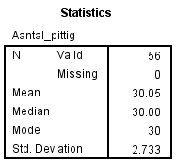

In the data above you can find the mean and median number of spicy nuts a bag of mixed nuts contains. What is the probability that a bag of nuts contains:

1. Less than 25 spicy nuts?

Z = (25-30.05)/2.733 = -1.85

P(Z<-1.85) = 0.0322 🡪 3.22%

1. More than 33 spicy nuts?

Z = (33-30.05)/2.733 = 1.08

P(Z<1.08) = 0.8599

1-0.8599 = 0.1401 🡪 **14.01%**

1. Between 28 and 31 spicy nuts?

Z = (28-30.05)/2.733 = - 0.75

Z = (31-30.05)/2.733 = 0.35

P(Z< 0.35) = 0.3632

P(Z<-0.75) = 0.2266

1 - 0.3632 – 0.2266 = 0.4102 🡪 **41.02%**